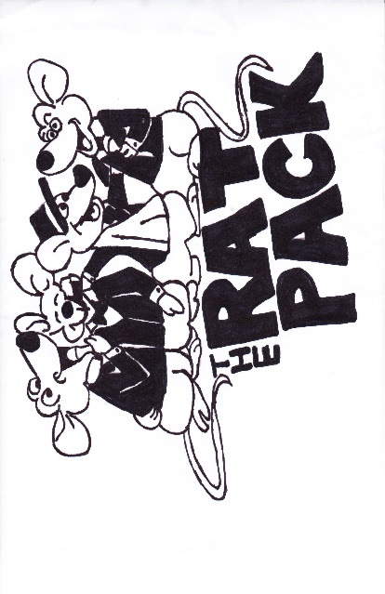

July 9-12 2025

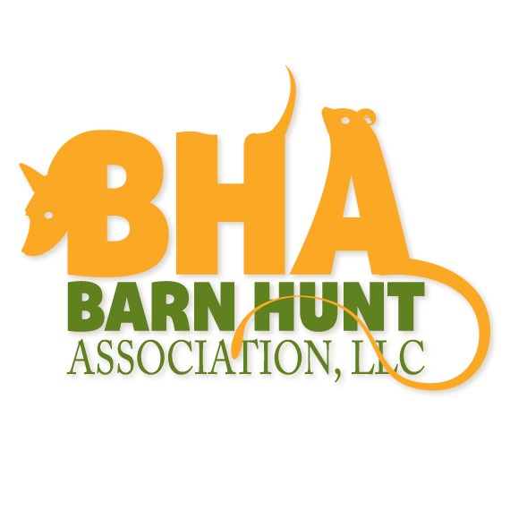
Jackson County Fairgrounds
1212 East Quarry Street
Maquoketa IA 52060
Judging panel:
JOR Catherine Hoese BHAJ-197A Mayer MN
JOR Lynsey Fuegner BHAJ-253A Maryville IL
JOR Liz Hawkins BHAJ-164A. Ft. Dodge IA
Classes offered:
Thursday Trial 1 Master
Thursday Trial 2----Crazy 8s
Friday Trial 1: Instinct, Novice, Open, Senior, Master
Friday Trial 2 Novice, Open, Senior, Master
Saturday Trial 1: Instinct, Novice, Open, Senior, Master
Saturday Trial 2: Novice, Open, Senior, Master
Sunday Trial 1: Instinct, Novice, Open, Senior, Master
Sunday Trial 2: Novice, Open, Senior, Master

There will be a short lunch break at the judge’s discretion. Move-ups will be allowed between trials on the same day and between days. Any JOR may judge any class.
Trial entry limits:
Thursday CZ8 and Master 35 runs per class.
Fri/Sat/Sun, 8 hours/240 MRV per judge
Pre-entry fees: Instinct $15; Novice-Senior; $25, Master $30, CZ8 $25
DOS entry fees Instinct $15, Novice-Senior; $27, Master $32, CZ8 $27

Entries open Monday May 25, 2026. Entries at the above fees will be accepted in the order received until closing date of Monday, June 29, 2026 at 6:00 PM with the Trial Secretary or until the maximum entry limit is reached. Day of Show entries will be accepted until trial limit is reached

Trial Officials:
Trial Committee: | Paul Morris, Robin Morris, Shelley Marvin, John Henely, Candy Henely
Trial Secretary: | Pat Saunders  1005 S 21st St  Fort Dodge, IA 50501  Pat.saunders50@hotmail.com  515-576-6460
Trial Chair: | Pat Saunders  1005 S 21st St  Fort Dodge, IA 50501  Pat.saunders50@hotmail.com  515-576-6460
DIRECTIONS TO TRIAL SITE:
WORKERS TAKE NOTE:
We need volunteers to help keep the trial running. If you have some time to help, please let us know. If you work a class you will get an entry into the worker raffle. Please give us three blinds of your time: Work a blind, potty your dog the next, run your dog the third.

EXHIBITOR INFORMATION:
All entries must be accompanied by entry fees to be valid. A returned check does not constitute a valid entry. There will be a $50.00 fee for all returned checks.
Dogs may enter both the Instinct test and Novice class in the same trial until the dog has earned the RATN title, after which they can no longer enter the Instinct test. Dogs earning a title in Trial 1 on Friday, Saturday or Sunday may be moved up, down, or laterally for Trial 2. Move-ups will be accepted each day for one-half (1/2) hour following the conclusion of the class. Move-up forms will be available at the Trial Secretary’s table.
All dogs must be on a short leash, under control and attached to a human while outside of their crate on trial grounds. Approved collars include flat snap or buckle collars of solid construction and covered, quick release prong collars. Leather, cloth, or nylon leads are allowed. Limited slip martingale collars are allowed. Single piece slip collars/ leads are allowed. Harnesses, with the exception of head-halter types, are allowed. Collars/harnesses which can be easily and quickly removed and replaced are strongly encouraged. Please bring a secure crate for your dog to relax in during times when they are not in the ring or are left unattended.
There is no smoking in the facility or on the grounds. If you must smoke, you will need to do so inside your vehicle and dispose of the butts in the vehicle also. Dog exercise areas will be marked, please pick up after your dog and dispose of waste in appropriate containers outside the building.

Dogs are required to have a Barn Hunt Registration number to show in Barn Hunt events. Register your dog online at www.barnhunt.com

Make checks payable to The Rat Pack. Send entries & fees to: Trial Secretary, Pat Saunders, 1005 S 21st St , Ft Dodge IA 50501. Email entry is offered for these trials email entry to yeagersmom2008@gmail.com; PayPal entry fees to yeagersmom2008@gmail.com. A $4 PER DOG convenience fee must be added to these entries.

The Rat Pack Schedule:

Building Opens:
Thursday at 9:00
Friday- Sunday at 6:30
Check In and DOS Entry:
Thursday 12:30-1:30
Friday-Saturday-Sunday -6:30-7:30
General and judges briefing:
Thursday 1:45
Friday-Saturday-Sunday 7:45
Judging Begins:
Thursday 2:00
Trial 1, Friday-Saturday-Sunday at 8:00
Trial 2 at 8:30

The run order and further scheduling details will be emailed to all competitors after the trial closes and the actual number of entries in each class is known. The Trial Committee reserves the right to change run order based on entries. Any judge listed in the premium is eligible to judge any classes offered.
Dogs being handled by the same person will be separated into different staged groups.

Height Divisions: Dogs 15” and under - Small
Dogs 15.1 to 22” - Medium
Dogs over 22” - Large
Awards: Ribbons will be awarded for first through fourth place in Novice A, Open A, Senior A and Master A & B classes in each height division. All other B classes will receive first through fourth place ribbons overall. Qualifying ribbons will be awarded for all qualifiers in the regular classes and the Instinct test. High In Class rosettes will be offered in Novice A, Open A, Senior A and both Master A and B classes. Title rosettes will be awarded to all dogs earning a title including CZ8, RATCH, RATCHX and higher.
These trials will be held indoors on a concrete floor; all rings will be fully matted. There will be crating space available, but make sure your crate is secure as the dogs may be highly excited. You may wish to bring a ground cover.
Please be considerate about picking up after your dogs and leaving the grounds as you found them. Any exhibitor failing to do so may be excused without benefit of refund if the Trial Committee deems the exhibitor to be in violation of the requirement per BHA regulations.
Bitches in Season: Bitches in season are eligible for entry, but will be required to be kept separate from all other dogs and will be run in panties at the end of their class. Entry fees for bitches that come into season will be refunded until Monday June 29,2026 if you wish to withdraw. No entry fees will be refunded after that date. If bringing a bitch in season, you must inform the Trial Committee prior to the trial and all exhibitors at the judge’s briefing.
Loud/Disruptive Dogs: Dogs that are loud and disruptive may be asked to locate away from the rings/crating area. Any dog behaving in a threatening or aggressive manner toward another dog or a person may be dismissed from the trial if justification is found to do so by the judge and/or Trial Committee. Terrier sparring is not allowed on the trial grounds.
Refunds: No refunds will be made after the entry deadline unless a replacement entry is available. Entry fees will not be refunded in the event that a dog is absent, disqualified, excused or barred from competition by action of the Trial Committee. No entry fee will be refunded if the trial cannot open or be completed by reasons of riots, civil disturbances, fire, acts of God, public emergency, an act of a public event or any other cause beyond the control of the organizing committee.

Hotels that will accept well behaved dogs (and owners).
Please contact hotel to verify pricing and policies.

The Decker Hotel
1289 Main Street
Maquoketa IA
563-652-1875
https://www.facebook.com/TheDeckerHouseHotel/
Mention Klimb classic when booking for pets to be allowed

Econolodge
1019 West Platt Street
Maquoketa, IA
563-652-6888

AmericInn
1910 Nairn Drive
Maquoketa, IA
563-652-0222
Mention Klimb when booking for $10 pet fee

In DeWitt (20 miles/23 minutes from event)

AmericInn
2520 12th Street
DeWitt IA
563-659-5500

Super 8 – DeWitt
918 Westwood Drive
DeWitt IA
563-659-8888

Camping is available on the grounds, visit http://jacksoncountyiowafair.com/ for details.

Camping is available at Maquoketa Caves State Park Maquoketa@dnr.iowa.gov

Camping is available at Lakehurst Riverside Campground campatthedam.com

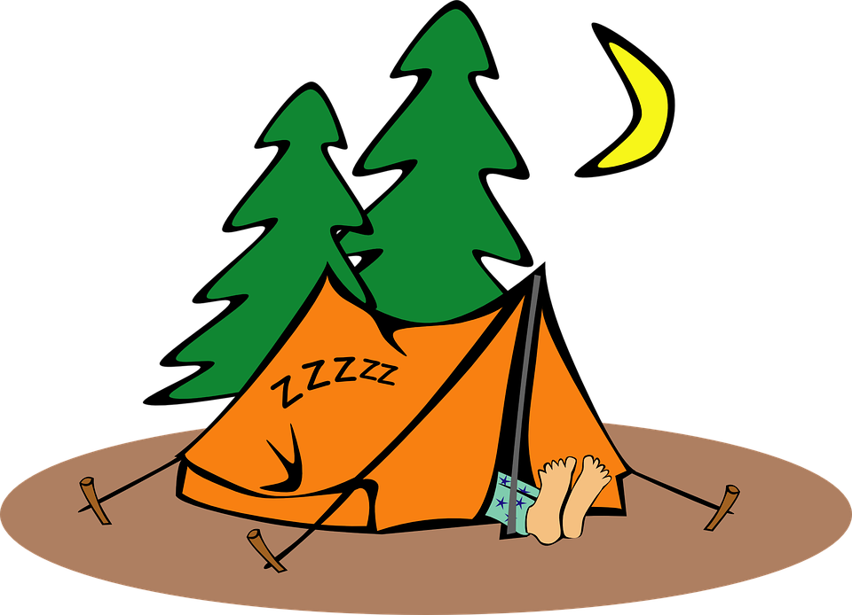

Tentative judging assignments are as below
Thursday Trial 1 |  | Instinct | Novice | Open | Senior | Master | Crazy 8s
 | Cathy Hoese |  |  |  |  |  | X
Thursday
Trial 2
 | Liz Hawkins |  |  |  |  | X
Fri Trial 1 |  | Instinct | Novice | Open | Senior | Master | Crazy 8s
 | Liz Hawkins | x | x | X
 | Cathy Hoese |  |  |  |  | X
 | Lynsey Fuegner |  |  |  | X
Fri.Trial 2 |  | Instinct | Novice | Open | Senior | Master | Crazy 8s
 | Liz Hawkins |  | X | X
 | Cathy Hoese |  |  |  | X
 | Lynsey Fuegner |  |  |  |  | X
Sat Trial 1 |  | Instinct | Novice | Open | Senior | Master | Crazy 8s
 | Liz Hawkins | X | X | X
 | Cathy Hoese |  |  |  | X
 | Lynsey Fuegner |  |  |  |  | X
Sat Trial 2 |  | Instinct | Novice | Open | Senior | Master | Crazy8s
 | Liz Hawkins |  | X | X
 | Cathy Hoese |  |  |  |  | X
 | Lynsey Fuegner |  |  |  | X
Sun. Trial 1 |  | Instinct | Novice | Open | Senior | Master | Crazy 8s
 | Liz Hawkins | x | X | X
 | Cathy Hoese |  |  |  | X
 | Lynsey Fuegner |  |  |  |  | X
Sun Trial 2 |  | Instinct | Novice | Open | Senior | Master | Crazy 8s
 | Liz Hawkins |  | X | X
 | Cathy Hoese |  |  |  |  | X
 | Lynsey Fuegner |  |  |  | X

PLEASE NOTE:

Any Judge of Record may judge any class. Judges are limited to 8 hours of judging. Judging schedule subject to change depending on entries received.

Big News for 2026: Swag Bags Are Back — Better Than Ever!
This year, we’re offering an optional, upgraded swag bag for just $25, available during pre-registration with Blue-9.
Why the change?
We know many of you are used to receiving a swag bag automatically — and we’ve loved gifting them in past years.
To keep the KLIMB Classic fun, affordable, and accessible for all, we’re now offering a value-packed version you can opt into during pre-registration.
What’s inside?
Special Blue-9 gear
Event t-shirt
Special surprises
More value than ever before
(Think treats, toys, training goodies — and a few surprises you won’t want to miss.)
Blue-9 proudly covers fairground costs and never takes revenue from sport registrations. Your swag bag purchase helps keep this community event going strong.
Here’s how it works:
Pre-register with Blue-9 to reserve your swag bag by June 24, 2026. Registration can be found on the KLIMB Classic webpage: https://www.blue-9.com/pages/klimb-classic
Then, pre-register for your sport of choice separately. Links to those events can also be found on the KLIMB Classic webpage
Show up in style — your swag bag will be ready at the event!
#KLIMBClassic #Blue9PetProducts #CanineFitness #SwagBagGoals #DogSportLife #KLIMBClassic2025 #DogEvents #DogLoversUnite

Official Entry Form
The Rat Pack
Licensed Barn Hunt Trial
Trial Date: July 10- 13, 2026
Closing Date: Monday, June 29 at 6:00 pm
Make Entry Fees Payable to: The Rat Pack
Mail Entries to: Pat Saunders, 1005 S 21st St, Fort Dodge IA 50501
Please check boxes for classes you wish to enter:
 | Instinct | Novice A B | Open A B | Senior A B | Master A B | Crazy 8s
Thursday
Fri Trial 1
Fri Trial 2
Sat, Trial 1
Sat, Trial 2
Sun, Trial 1
Sun. Trial 2

Fees: $15 Instinct; $25 Novice-Senior; $30 Master; $25 Crazy 8s

Day of Show Entry Fees: $15 Instinct; $27 Novice-Senior; $32 Master; $27 Crazy 8s

Please check here if you may earn a RATCH, RATCHX or Crazy 8s title at our trial!________
Registered Name: _____________________________________________________________
BH#: BH-__________________ Call Name: ________________________________________
Sex: ___________ Breed: ______________________________________________________
Height at Withers: ______________ Birth Date: ________________________________________
Actual Owner(s) (please print): ____________________________________________________________
Owner’s Address: _______________________________________________________________________
City: _______________________________________________ State: ________ ZIP: ________________
Phone: ________________________________________________________________________________
Email: _________________________________________________________________________________
Handler if Other than Owner: _______________________________________________________________
CERTIFICATION OF AGREEMENT UPON ENTRY OF DOG:
I certify that I am the actual owner of the dog, or that I am the duly authorized agent of the actual owner whose name I have entered above. In consideration of the acceptance of this entry, I (we) agree to abide by the rules and regulations of the Barn Hunt Association, LLC in effect at the time of this event, and by any additional rules and regulations appearing in the premium list for this event, and further agree to be bound by the liability waiver enclosed with my entry. I (we) certify and represent that the dog entered is not a hazard (dog or human aggressive) to persons or other dogs. This entry is submitted for acceptance on the foregoing representation and Agreement. I (we) agree to conduct myself (ourselves) in accordance with all Barn Hunt Association, LLC Rules and Regulations and to abide by any decisions made in accord with them.
______________________________________________________ ______________________
Signature of owner or his agent authorized to make this entry Date

Liability Waiver
I (we) agree that the club holding this event has the right to refuse this entry for cause which the club shall deem sufficient. In consideration of the acceptance of this entry and of the holding of this event and of the opportunity to win prizes, ribbons, and/or trophies, I (we) agree to hold Barn Hunt Association, LLC, the event-giving club, their members, directors, governors, officers, agents, or event secretary and the owner and/or lessor of the premises and any provider of services that are necessary to hold this event and any employees or volunteers of the aforementioned parties, and any BHA LLC approved judge, judging at this event, harmless from any claim for loss or injury which may be alleged to have been caused directly or indirectly to any person or thing by the act of this dog while in or about the event premises or grounds or near any entrance thereto, and I (we) personally assume all responsibility and liability for any such claim; and I (we) further agree to hold the aforementioned parties harmless from any claim for loss, injury or damage to this dog.
Additionally, I (we) hereby assume the sole responsibility for and agree to indemnify, defend and save the aforementioned parties harmless from any and all loss and expense (including legal fees) by reason of the liability imposed by law upon any of the aforementioned parties for damage because of bodily injuries, including death at any time resulting therefrom, sustained by any person or persons, including myself (ourselves), or on account of damage to property, arising out of or in consequence of my (our) participation in this event, however such, injuries, death or property damage may be caused, and whether or not the same may have been caused or may be alleged to have been caused by the negligence of the aforementioned parties or any of their employees, agents, or any other persons.
________ By initialing here, I indicate my agreement with the above Liability Waiver.

Media Release Form
I hereby authorize club-appointed videographer and/or photographer to use, reproduce, and/or publish photographs and/or video that may pertain to me, including my image, likeness and/or voice without compensation. I understand that this material may be used in various publications, public affairs releases, recruitment materials, the BHA LLC website, Yahoo! Group or Facebook page, or for other related endeavors. This authorization is continuous and may only be withdrawn by my specific rescission of this authorization. Consequently, the BHA, LLC or show-giving club may publish materials, use my name, photograph, and/or make reference to me in any manner that the Corporation or project sponsor deems appropriate in order to promote/publicize service opportunities.

________ By initialing here, I indicate my agreement with the above Media Release Form.

YOUR ENTRY MUST BE COMPLETE WITH BHA REGISTRATION NUMBER AND SIGNED, WITH LIABILITY WAIVER INITIALED.

NO INCOMPLETE ENTRIES WILL BE ACCEPTED

